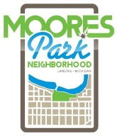 MOORES PARK NEIGHBORHOOD ORGANIZATION (MPNO)
REGULAR MEETING AGENDA
Monday, December 5th, 2016

Come to Order: 6:30pm, St. Casimir Church

1. Additions/deletions to the agenda
2. Introductions
3. Approval of September Meeting Minutes

4. Officer Reports-
Natalie Molnar, President president@mooresparkneighborhood.com
Matthias Bell, Vice President vp@mooresparkneighborhood.com
David Potts, Treasurer
Mike Prohaska, Secretary

5. Business
- Neighborhood Survey Results
- Sign / Block Grant Update
- Upcoming Grants
- Committee Formations and Meetups

6. New Business
- Open

7. Community Events & Announcements

8. 8pm Adjourn

For details on any of the above events, please visit www.mooresparkneighborhood.com. Meeting minutes are typically posted to the website within a week.

